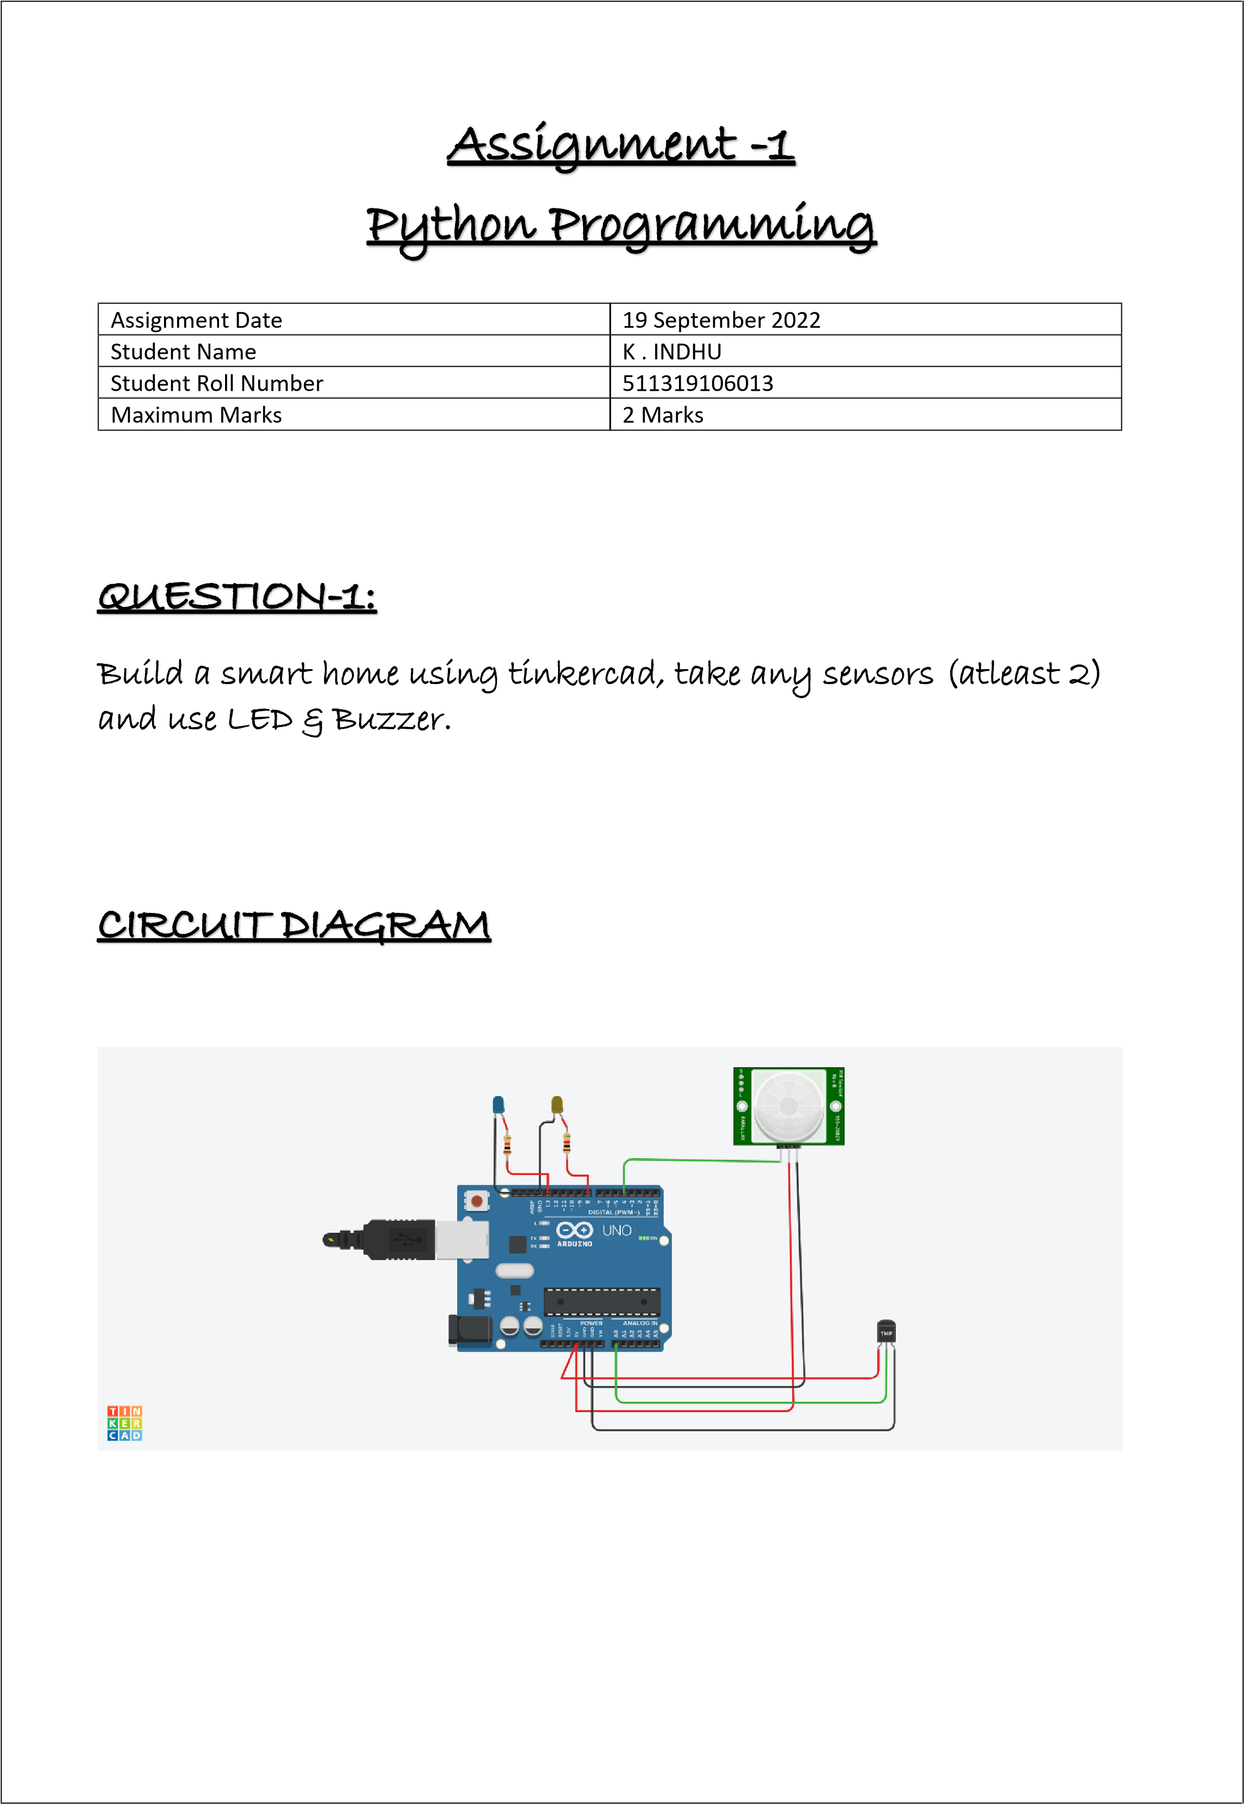

|  |
| --- |
| void setup()  {  Serial.begin(9600); pinMode(4,INPUT); pinMode(8,OUTPUT); pinMode(13,OUTPUT);  }  void loop()  { int p=digitalRead(4); Serial.println(p); if(p) {  digitalWrite(13,1);  Serial.println("motion detected");  }  delay(1000);  double a=analogRead(A0);  double t=(((a/1024)*5)-0.5)*100;  Serial.println(t); if(t>25) {  digitalWrite(8,1);  Serial.println("temperature greater than 25"); delay(1000);  }  } |